**ECE 403**

SENIOR DESIGN II-OPTIONS CONSIDERED DOCUMENT

9/27/2013

Jake Schulzetenberg

Andrew Widmer

Thomas Schwandt

Introduction.

This is an interactive display for the purpose of expressing different sounds, for example those of animals. In this specific project different calls of birds will be expressed for the purpose of educating visitors at a zoo. The device will be interactive with the user with no physical touch required. It will use sensors that will individually represent certain animal sounds. The unit to be constructed is specifically designed for that of a zoo, but there’s nothing restraining it from being used in other applications. The unit will also consist of a display expressing different information such as weather.

## Previous Work

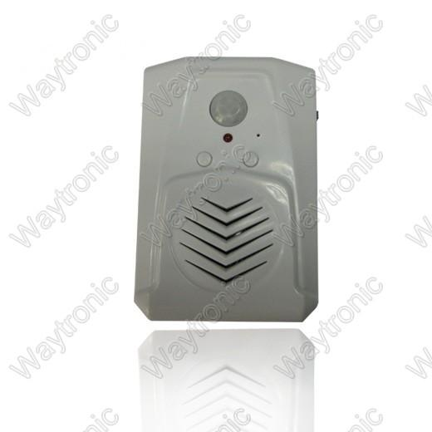

Motion Activated Speaker for Product Campaign (www.waytronic.com/products_show.asp?/11.html)

This is just one of the many motion sensor speakers that are in today’s electronic market. There are others such as the PowerSound PIR Motion Sensor Speaker, SmartSound PIR Motion Sensor Speaker, etc. This is similar in many ways. It can have different MP3 files loaded onto an internal flash memory using a micro SD card, it has adjustable volume. It however is battery powered and has a max sensing distance of five meters.

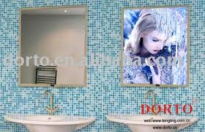

Slim Magic Mirror

The slim magic mirror is used frequently for advertising. It appears as a mirror and as you approach it the mirror seemingly disappears and a piece of advertisement appears, or vice versa. This is similar to the product to be created in the way that it sends an output based on motion.

[www.alibaba.com](http://www.alibaba.com)

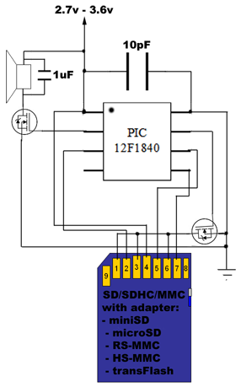

Dmitry Grinberg has developed an audio player using a single PIC processor and a SD card for storage of the WAV audio files. The PIC12F1840 processor was chosen for its fast clock rate. The speaker is powered with a MOSFET amplified signal coming from the PWM output on the PIC. The SD card driver was custom made. Timers were used for sound playback timing and PWM timing.

There are numerous **patents** related to motion detecting devices and so it seems unnecessary to list each. A patent search was done but it was thought that there wouldn’t be a specific patent related to a product such as an animal display related directly to a certain zoo.

### Design Options

The objective behind this product is to create a unit that produces a sound through some sort of interface with a user. In our previous document the requirements of the overall objective were listed and these are the differing approaches.

**Apps for Phones and Tables:**

Our initial idea was to develop an app that was able to connect to our display wirelessly and could be used with phones and tablets. We wanted to develop a product that was cutting edge, and the portable electronics market is large. After reviewing the pros and cons of creating the different kinds of apps, we have chosen to create a display that is self-sufficient and does not rely on a device from the user. This will make sure that all the guests to the zoo will be able to use and enjoy our display, including children.

**HTML5 web app:**

**Disadvantages**

* No way to access Bluetooth or WIFI on android or iPhone without a dedicated app installed on the device, not able to transmit data to the device.
* Web app can be built quickly using previous website building knowledge.

**Advantages**

* Cross compatible with any device that has a web browser.
* Can be made to visually mimic a dedicated app.
* Nothing to download, accessible from any web browser.

**iPhone & Android apps:**

**Disadvantages**

* Requires regular updates to make the app work across all devices as new phones and software hit the market.
* There is a learning curve for working with the software to develop the app.
* Other phones that do not have iOS or Android operating systems will not be supported if we only make a iPhone and android app.

**iPhone app:**

**Disadvantages**

* Required to pay a $99 yearly fee in order to sell the app in the Apple App Store.
* Requires knowledge of Objective-C programming language.
* Steep learning curve for creating first iPhone app.
* App needs to get approved for the app store.
* Need a Apple computer with an Intel processor to create the app.
* Direct control of Bluetooth is prohibited by Apple app guidelines.
* Need to use WIFI in order to transmit data to the device.

**android app:**

**Disadvantages**

* Pay one time registration fee of $25.
* Needs to be functional over a wide range of devices that use Android OS.

**Advantages**

* Code written in Java, which is familiar

app can access Bluetooth and WIFI to transmit data.

As stated above, the options were weighed relating to use of an app through a cellular device and the decision to have the display be self-sustained and interactive without requiring external devices was decided.

### Parameter: Interaction with User

Touch or no touch interface.

Using sensors was decided upon. A interface that requires touch whether that be buttons, etc. would be subject to wear and tear.

### Parameter: Types of sensors.

**Light Sensor.**

This is **disadvantageous** because there are no perfect conditions that could be designed for in order to make light sensors work efficiently. Light is so relative and subject to change based on season, time of day, weather patterns, inside or outside, etc.

**Sound Sensor.**

This is **disadvantageous** because a zoo is generally a loud environment. The sensors would either be too sensitive and therefore making sounds at improper times or not sensitive enough and require yelling in order to operate. Also producing a specific user sound for a specific animal sound would produce errors because the sensor would often times have difficulty picking up the correct sound amidst the many other sounds.

**Touch Sensor.**

**ADVANTAGE**. Touch sensors would allow the product to produce different animal sounds based on which part of the display was being touched. This would ensure that the right sound was emitted as desired opposed to sound.

**DISADVANTAGE**. A touch sensor would create a problem because the maintainability and durability. This display would be outside for a portion of the year and would also be interacted with very often. A touch sensor would be subject to wear and tear if used in such an application.

**Altitude/height Sensors.**

The only way considered in using an altitude sensor was having it attached to a physical interface that you would manually lift to different height locations that were associated with different desired sounds.

**ADVANTAGE**. Only requires one sensor.

**DISADVANTAGE**. Would require many moving parts that would produce wear and tear and would therefore require much extended maintenance.

**Motion Sensor.**

**ADVANTAGES**. A motion sensor would not require any physical touch between the user and the unit. Having it not based on sound you can still ensure that the desired animal sound is produced because each sensor would be programmed to a certain sound. Using motion sensors would allow us to place the sensors behind a form of protective encasing display.

**DISADVANTAGES**. The majority of motion sensors on the market have sensing ranges of around 5 to 10 meters. This would create many false activations of the sensor, and consequently, the display. Sensitivity might be able to be reduced in software, or by reducing the visibility that the sensor has. The price of a motion sensor is also higher than some of the other sensors that could be used and would require a higher quantity.

**Proximity Sensor.**

**ADVANTAGES**. A proximity sensor would also require no physical contact between the user and the sensor itself. Proximity sensors could also be placed behind a form of protective encasing display. Proximity sensors also have a much smaller sensing range, many within 0.2 meters.

**DISADVANTAGES**. There are many different types of proximity sensors, many of which have a much higher price than some of the aforementioned sensors.

It was decided that either a motion sensor or a proximity sensor would be the best choice to meet our requirements. Although having a higher cost, it seems to be the most reliable, the less likely to break down, and will be the best at producing product quality.

### Parameter: Type of Motion Sensors

There are four main types of sensors used as motion detectors:

1. Passive Infrared
2. Ultrasonic
3. Microwave
4. Tomographic Motion Detector

An Ultrasonic sensor emits ultrasonic waves and measures the time between the pulse and the moment that the wave reflected back to the sensor. The disadvantages of this sensor however are that it has a minimum distance, which if looked into might not be effective for the unit because it is best at a small distance range, it also needs to have perpendicular collisions to be effective, and it is also expensive as many are > 100$. Also by emitting waves it has a large power consumption.

A microwave sensor in a similar fashion emits electromagnetic pulses and measure the change in frequency due to the reflection from the object. These are not as expensive as the ultrasonic as some can have a price near 10-15$. However, because it emits pulses it produces unnecessary power consumption.

Tomographic Motion Detector sense disturbances to radio waves as they pass between points of a mesh network. This would be an unnecessary sensor to use in our application. It would also be costly.

Passive Infrared sensors detect body heat as it changes in respect to the surrounding environment. As it is passive no energy is emitted from this sensor. A PIR detects motion in real time. It can be used at shorter distances. It has a higher cost as many range around 10$.

### Parameter: Type of Proximity Sensors

There are many types of proximity sensors, the most common being:

1. Infrared Photocell
2. Capacitive
3. Inductive
4. Magnetic
5. Radar/Sonar

Many of these types of proximity sensors immediately become disadvantageous to us for this project including Inductive, Magnetic, and Radar/Sonar. Inductive proximity sensors only sense metallic objects, which in this project, we are assuming most people will be using their hand to activate the sensors. Magnetic proximity sensors require a magnetic object to disrupt the sensor’s magnetic equilibrium to activate. Radar/Sonar proximity sensors emit radio waves to detect objects. This would create a large and unnecessary power consumption.

Infrared Photocell proximity sensors use the reflection of infrared light off of detected objects to detect activity. The majority of these sensors have sensing ranges around 0.2 meters up to a maximum of 0.8 meters. IR Photocell sensors have a price range from around $3 up to $15.

Capacitive proximity sensors use human body capacitance as input. They can also detect anything that is capacitive or has a dielectric different than air. These sensors can also measure things such as humidity and fluid level or placement. Capacitive proximity sensors have a price range from around $10 up to $200. The sensors on the lower end of that range include what would basically be a capacitive touch sensor.

It was decided that either Passive infrared motion sensors, Infrared Photocell proximity sensors, or Capacitive proximity sensors would be the best choice for this unit. Each of these sensors has their own advantages and disadvantages, therefore we will be testing numerous different sensors from these three types during our prototyping phase and then selecting the most appropriate to use in the final finished product. This is described in more detail in our budget section. The sensors we will be testing and deciding from are;

* 1. Sharp GP2Y0A21YK - Infrared Proximity Sensor – Sparkfun SEN-00242
  2. Standalone Momentary Capacitive Touch Sensor Breakout - AT42QT1010
     + <http://www.adafruit.com/products/1374#Description>
  3. SENSOR MOTION PIR – PIR Motion Sensor – Digi-Key 255-3075-ND
  4. SENSOR DGTL PROXIMITY OPT – IR Proximity Sensor – Digi-Key 516-2663-1-ND
  5. PHOTOCELL – Light Sensor – Digi-Key PDV-P9103‐ND, PDV‐P8006‐ND, PDV‐P5002‐ND, or PDV‐P8005‐ND

### Parameter: Microprocessor

Our project will require a processor to be able to make our project function. We looked into using and ARM. It was considered because we knew that ARMs might be applicable in the future when looking into jobs. We decided to use a PIC because by using a microprocessor that we are familiar with so that we could focus more on the hardware and programming aspect instead of trying to understand one microprocessor and get stuck behind that learning curve.

We needed to look at the different characteristics required for a Microprocessor we would be using. Our Micro will need basic functionality, some of these being: able to input and output voltage signals and current, input and output different frequencies, operate at a temperature suitable to our environment, no major size constraints, capable memory, capable speed and more. In analyzing these needs we decided upon the PIC18F4620.

### PIC18F4620

This is the microprocessor we use in Embedded Systems. We don’t have major memory requirements because our design calls for an external SD card which will have sufficient memory (for this reason memory is not a constraint and EEPROM or FLASH memory is not a required part) The PIC has 64K bytes of Flash program memory. The PIC has 36 input/output pins. This should be more than sufficient for our number of sensors being used and other project related parts. Citing page 321 of the datasheet we can see the operating temperatures of the PIC, it can operate from -40°C to 125°C. It can output or sink +or- 25 mA from any Input/Output pin, which will be sufficient with our design. The PIC can operate from DC to 40 MHz which is more than sufficient for our project. The operating voltage is 2 to 5.5 V. It also will be able to run at a speed (CPU Speed = 10) sufficient for our processes. For more information on current ratings and temperature ratings we can consult page 321 of the datasheet. Also due to personal preference we prefer it to be through hole instead of Surface mount.

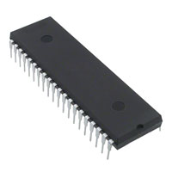

### Parameter: Memory

#### BOB-11403

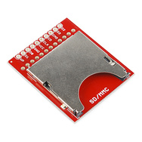For data storage of the audio files, the project uses a SD card. This was chosen because of the availability and low prices of SD cards. In order to connect the SD card with the PIC, a breakout board is necessary. One was found on Sparkfun, and this will allow us to solder the breakout board to the project while being able to remove and update the SD card at will. No special requirements are necessary for this breakout board, just one that is reliable and fully functional. $9.99

### LED Display

An LED Display is in mind to be used to display things such as time, weather, temperature, etc. A certain one is not picked out yet because more needs to be thought through of how the PIC will connect information with it. We are thinking through size requirements, but will allot between 50 and 100 dollars.

### Parameter: Audio

### Speaker

The speaker chosen was the GF1004 sold by Digi-Key. This speaker is rated at 6W of power at 8 ohms. The speaker has a frequency range up to 17kHz, which will be sufficient in producing all the animal sounds. This speaker has the highest SPL (93dB) of comparable speakers on the Digi-Key website. Other speakers were looked into on Digi-Key but this one fully meets any design requirements and audio requirements foreseen needing, and is cost-effective. $8.29

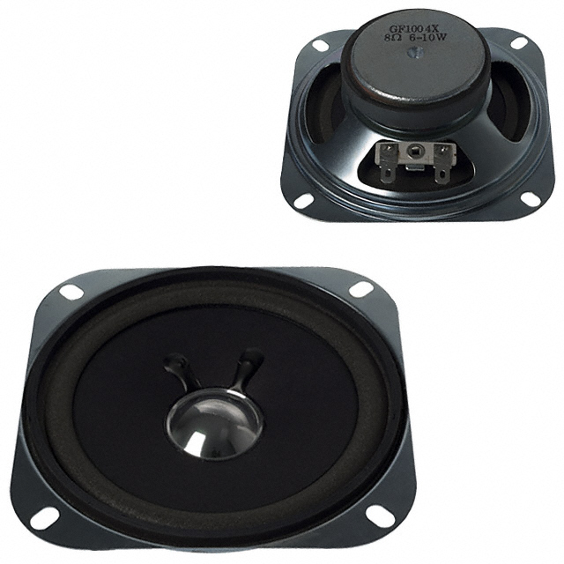

### Variable Volume – Potentiometer

To vary the volume of the speaker, the use of a variable resister is needed. A logarithmic potentiometer will be the best pick to use in line with a speaker, as perception of audio volume is logarithmic to the human ear. The specific part that was selected was the PTD901-2015K-A102. It was selected because of its low price, low resistance (1k ohm), and low power consumption (1/40W). $1.08287

Other variable resistances were looked into with a variable resistance of 500 ohm but their use was declined because our design should not require that low of variable resistance to produce low current.

### Parameter: Power Supply

#### T1058-P5P-ND

This is a AC to DC wall adapter that converts 120 V AC rms to 5 V DC. This is the power we need to operate our PIC and our design. The current output is 2.5 A which will be sufficient for our current supply. No special constraints are needed for this other than current and voltage. No durability is necessary because the power supply will be inside our encasing.

### Parameter: Display

#### Front Of Display

Acrylite Resist 65 is ideal for being used for the top of our display because of its strength, appearance, and durability in the outdoors. We will be using a 3’ X 3’ X .25’’ piece of acrylic for the display.

Different types of material were shortly considered, however acrylic, which is similar in appearance to plexi glass is to be used because of the benefits it provides in aesthetics and protection to sensors.

Cost $10+$10.39 shipping

#### Other parts yet to be considered:

Lock for display

Encasing for display

BUDGET:

In our prototype phase we will be constructing five to seven prototypes of our circuit. We would like to test this number of sensors to test which would best meet our requirements. We will build the prototype of the five different sensors and test them against our requirements. Our budget will show this, we will be purchasing three of each sensor so that we can have spares and we can give them back to be used by the department. We will include extra expenses based on spare parts and based on the amount of money set aside to be used to purchase the sensors we do see fit post prototype stage.

|  |  |  |  |  |  |
| --- | --- | --- | --- | --- | --- |
| Part | Unit Cost | Quantity | Total Cost | Digi-Key part | Comments |
| PIC18F4620-I/P-ND | 6.25 | 1 (no spares necessary- readily available) | $6.25 | PIC18F4620-I/P-ND | Microprocessor |
| Acrylite Resist 65 | $150 +$10 shipping | 1 | $160 |  | DISPLAY COVER Cost subject to change based on size requirements |
| GF1004 | $8.29 | 2 | $16.58 | GF1004 | Speaker |
| PTD901-2015K-A102 | $1.08287 | 2 | $2.16 | PTD901-2015K-A102 | Potentiometer |
| BOB-11403 | $9.99 | 1 | $9.99 | BOB-11403 (SparkFun Part) | Breakout Board, SD interface |
| LED display |  | 1 | $50<price<$100 |  | LED display |
| Photocell-Light Sensor | $1.86 | 3 | $5.48 | PDV-P9103‐ND, PDV‐P8006‐ND, PDV‐P5002‐ND, or PDV‐P8005‐ND | Light sensor |
| EPSA050250U-P5P-EJ | $12.30 | 1 | $12.30 | T1058-P5P-ND | Power supply |
| IR Proximity Sensor | $13.95 | 3 | $41.85 | SEN-00242 (Sparkfun) |  |
| Capacitive touch sensor | $5.95 | 3 | $17.85 |  |  |
| Sensor Motion PIR | $10.26 | 3 | $30.78 | 255-3075-ND |  |
| SENSOR DGTL PROXIMITY OPT | $4.07 | 3 | $12.21 | 516-2663-1-ND |  |
| Thermistor PTC | $.90 | 3 | $2.70 | 490-2075-ND |  |
| SD card 2G or 8G Memory | $8 | 1 | $8 |  |  |
| Poster Display | Quote $30 |  | $30 |  | (behind plexiglass) |
| Display encasing | Yet to be decided |  | $150 |  |  |
| Excess Possible Parts, i.e temp sensor |  |  | $50 |  |  |
| IC Barometer | $2.74 | 3 | $8.22 | MPL115A2T1CT-ND |  |
| Sensor Capacitive Humidity SIP | $4.32 | 3 | $12.96 | 480-2904-ND |  |
|  |  |  |  |  |  |
|  |  |  |  |  |  |
|  |  | **TOTAL** | **$652.33** |  |  |
|  |  |  |  |  |  |

# TIMELINE

|  |  |  |
| --- | --- | --- |
| Task | Week of Semester | Who |
| 1. Requirements, etc, etc | Prior to wk 5 | Team Rocket |
| 1. Options Considered | 5 | Team Rocket |
| 1. Order Sensors, Breakout Board | 6 | Andrew, Tom |
| 1. Continued Research-speaker, ME dept. enclosure | 6 | All |
| 1. Pick out some audio sounds for file transformation | 6 | Jake |
| 1. Meet with Dr. Glower to discuss audio files transformation Tu, Th | 6, 7 | Team Rocket |
| 1. Possibly go with Dr. Glower to zoo, Tuesday | 6 | Andrew Tom |
| 1. Pick scrolling Display | 8 | Team Rocket |
| 1. Analysis of Circuit, expected voltages, currents | 8,9 | Team Rocket |
| 1. Design Circuit for a sensor (multisim, etc.) | 8, 9 | Team Rocket |
| 1. Test Design Circuit | 8,9 | Team Rocket |
| 1. Design Physical Circuit | 10, 11 | Team Rocket |
| 1. Software program for PIC | 10, 11 | Team Rocket |
| 1. Duplicate circuit for each required sensor | 11,12 | Team Rocket |
| 1. Test Circuit for Proper Analysis and Functionality, i.e. expected voltages, currents | 12,13 | Team Rocket |
| 1. Compare Requirements to Test Data-requirements fulfillment | 13,14 | Team Rocket |
| 1. Revise Schematic In multisim if necessary | 13,14 | Team Rocket |
| 1. Prepare for Presentation | 15 | Team Rocket |
| 1. Prepare PCB layout | 15,16 | Team Rocket |
| 1. Presentations, end of semester | 16 | Team Rocket |

Note*****We realize that instructions say to assign members doing each duty. We took that into consideration and we will all most likely do above tasks as specified in column C.

|  |  |  |  |  |  |  |  |  |  |  |  |  |  |  |  |
| --- | --- | --- | --- | --- | --- | --- | --- | --- | --- | --- | --- | --- | --- | --- | --- |
| Week 1 | 2 | 3 | 4 | 5 | 6 | 7 | 8 | 9 | 10 | 11 | 12 | 13 | 14 | 15 | 16 |
| Task 1 | X | X | X |  |  |  |  |  |  |  |  |  |  |  |  |
| 2 | X | X | X | X |  |  |  |  |  |  |  |  |  |  |  |
| 3 |  |  |  |  | X |  |  |  |  |  |  |  |  |  |  |
| 4 |  |  |  |  | X |  |  |  |  |  |  |  |  |  |  |
| 5 |  |  |  |  | X |  |  |  |  |  |  |  |  |  |  |
| 6 |  |  |  |  | X | X |  |  |  |  |  |  |  |  |  |
| 7 |  |  |  |  | X |  |  |  |  |  |  |  |  |  |  |
| 8 |  |  |  |  |  |  | X |  |  |  |  |  |  |  |  |
| 9 |  |  |  |  |  |  | X | X |  |  |  |  |  |  |  |
| 10 |  |  |  |  |  |  | X | X |  |  |  |  |  |  |  |
| 11 |  |  |  |  |  |  | X | X |  |  |  |  |  |  |  |
| 12 |  |  |  |  |  |  |  |  | X | X |  |  |  |  |  |
| 13 |  |  |  |  |  |  |  |  | X | X |  |  |  |  |  |
| 14 |  |  |  |  |  |  |  |  |  | X | X |  |  |  |  |
| 15 |  |  |  |  |  |  |  |  |  |  | X | X |  |  |  |
| 16 |  |  |  |  |  |  |  |  |  |  |  | X | X |  |  |
| 17 |  |  |  |  |  |  |  |  |  |  |  | X | X |  |  |
| 18 |  |  |  |  |  |  |  |  |  |  |  |  |  | X |  |
| 19 |  |  |  |  |  |  |  |  |  |  |  |  |  | X | X |
| 20 |  |  |  |  |  |  |  |  |  |  |  |  |  |  | X |

# SUMMARY

The objective of our project is to create an interactive display that could work at a location such as a zoo. We want it to be easy to use and we want it to contain different types of audio and be capable of a larger quantity of sounds if necessary. We have looked into different options considering how we’d interface with users such as mobile app devices and we’ve decided that a different route should be considered due to the age category we are targeting and because of the availability and cost of mobile app devices. For these reasons we will be designing a unit using sensors. We are proposing to use the prototype stage of our project to test different types of sensors that we’ve researched to see will fit our objectives to see which will work the best according to our requirements. Our proposed budget displays extra funds towards buying different types of sensors. In general this is moderately inexpensive and will be useful to the overall outcome of our project. WE also have extra costs related to our budget because of our desire to use an SD card as our source of memory instead of an external flash memory for the micro. We decided upon this because this would allow us to put new sounds into the display without having to reprogram the circuitry.